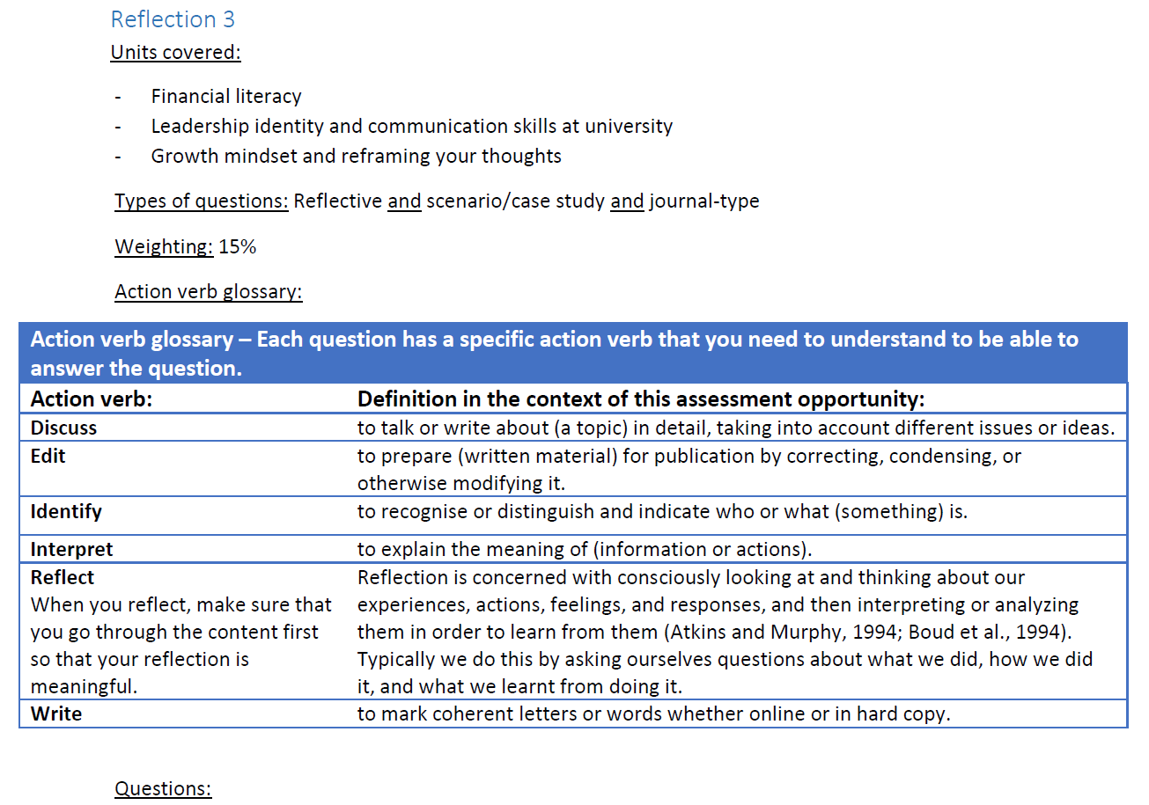

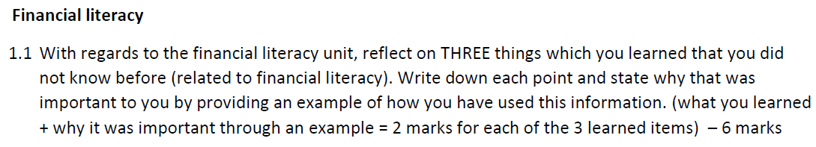

|  |
| --- |
| * Communicate with your funder – it is paramount to communicate with your funder to send your tuition account fee because the contract is between you and the institution or else you will be blocked. * Budgeting – having saving account reduces your spending, as a student you must avoid spending money reckless. * Tracking of tuition account – knowing difference between debit, credit and calculating your fees. |



|  |
| --- |
| * Work to obtain merit award bursary – you will be given bursary automatically if student got average of 75% an above and that will save your money. * Saving account – it reduces the way you use your money on expenses and unnecessary things like alcohol and etc.. |

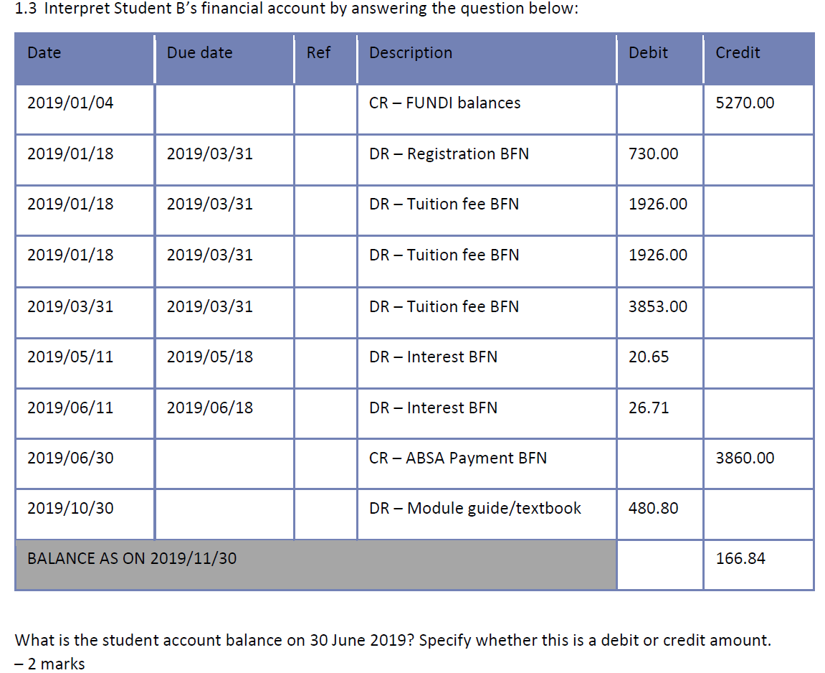

|  |
| --- |
| * R 3860.00 |

**Leadership identity and communication skills at university**

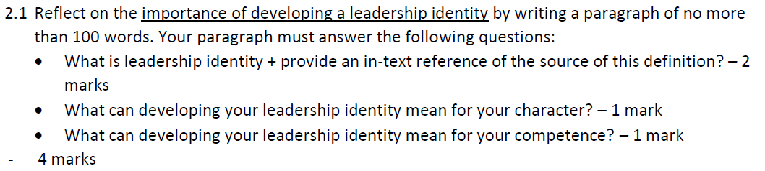

|  |
| --- |
| * Leadership identity – is someone who have confidence and ability to lead a certain group of people for example a pastor. The cumulative confidence in one’s ability to intentionally engage with others to accomplish group objectives (Komives et al.:2005). * It could change my appearance and competence in my society. * It would make me more useful and true leader as I will be functional and active. |

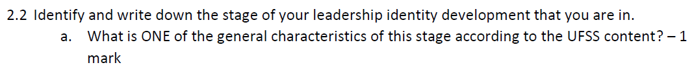

|  |
| --- |
| * Stage 2 – Individual intentionally become involved in groups. |



|  |
| --- |
| * Individual join a sport team and they are tasked with responsibilities. |



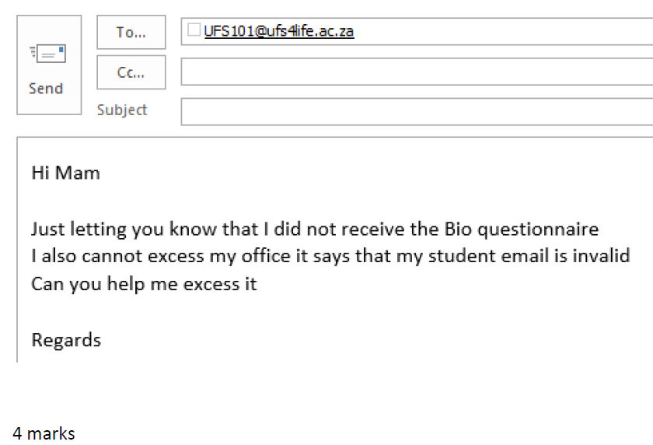

|  |
| --- |
| * Student number (2018906323) * Module code (UFSS1504) * Name and surname of student * Subject for queries |

**Growth mindset and reframing your thoughts**

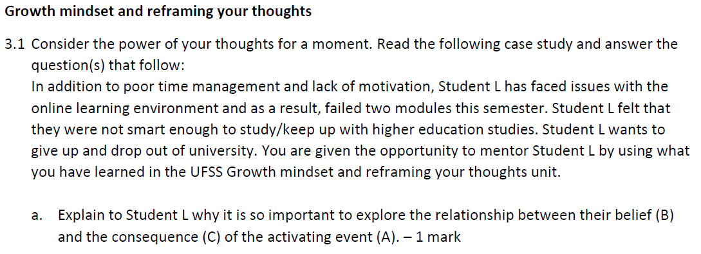

|  |
| --- |
| * It is paramount to explore alliance between belief and consequences, because what you think or belief influence the way you react to situation that is out of your control and it might results in negative reaction for example consumption of alcohol. |

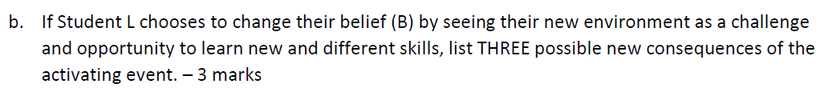

|  |
| --- |
| * Student L can learn what he did wrong and chose to make it right. * Change study habits and it will result in him passing that failed modules. * Student L can achieve his all desires academic. * He will not drop out of varsity |

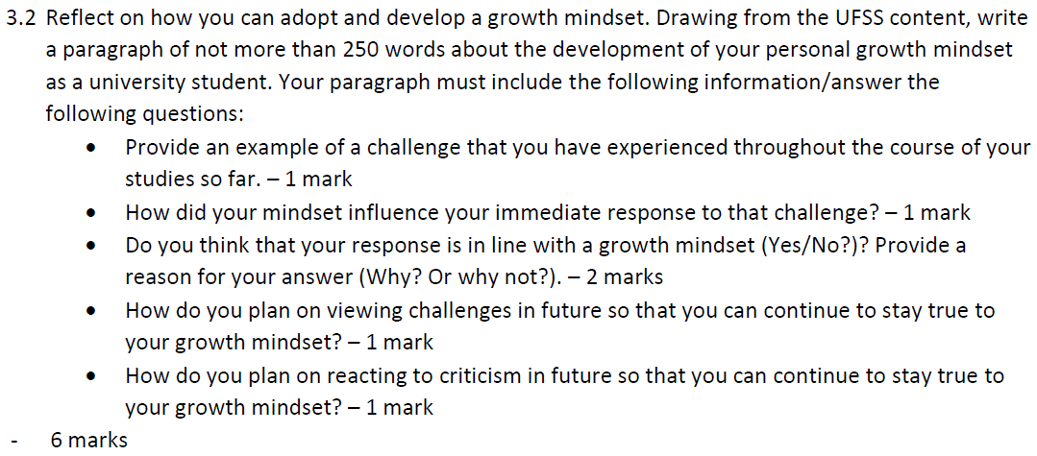

|  |
| --- |
| * It was my first time being exposed to online learning and I have been struggling to cooperate and attend classes as some were clashing. I felt like giving up or take me back to high school but I told myself I will adapt eventually so. My response towards that situation was in line with growth mindset because I acknowledged my imperfections, as I used learning instead of failing. In future I will view challenges as opportunity for me to learn and word hard to win those challenges by achieving my goals. I will always welcome criticism that come my way and also not let it to get into my head just banish it. |

